The web url is 192.168.0.1, so please make sure you are on that address before continuing.

Upon starting up you will be presented with a home page which also serves as the status page for any active devices that you have set up and connected. See image below for an example of .

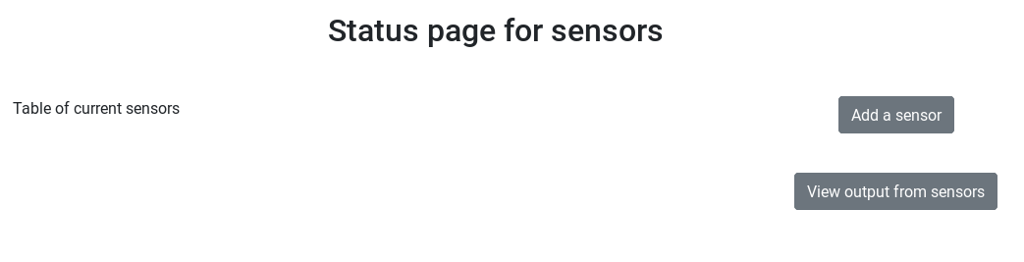

To add a sensor, click on the “Add a sensor” button in the top right of the page. This will re-direct you to a new page where you can see all attached devices, and allows you to select one, and then select the sensor type that it is from the list below. Please see image below for reference where there are no sensor devices attached.

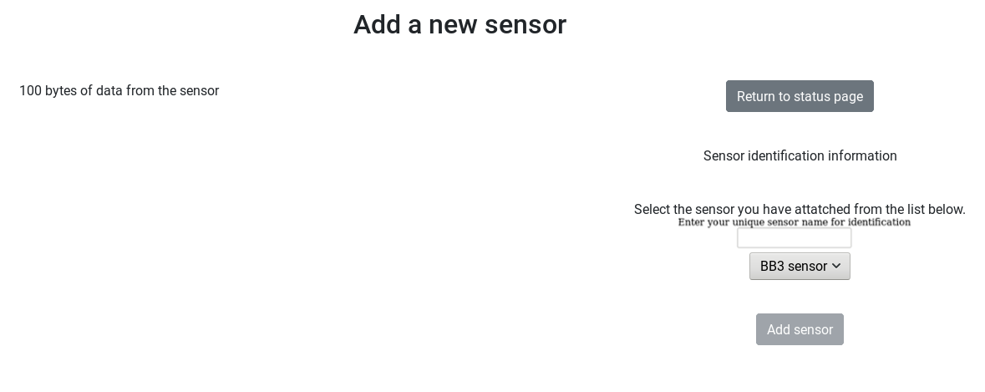

When a sensor device has been attached, a table listing the devices will appear on the right hand side.

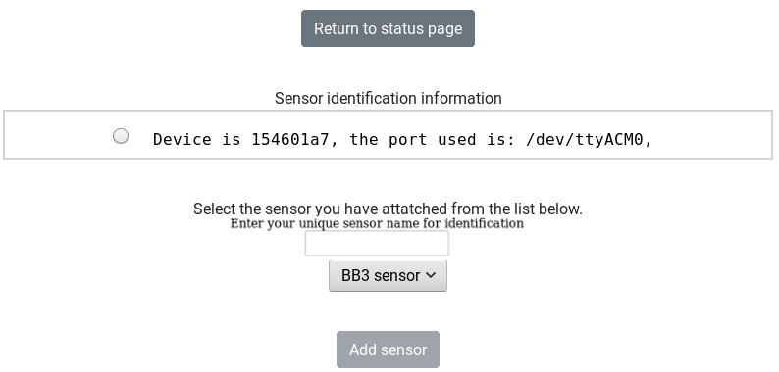

To start reading data from the device, you must follow these steps:

1. Select the device using the button on the left of the device description.

2. Select the sensor type from the drop down list.

3. Click the button “Add sensor”.

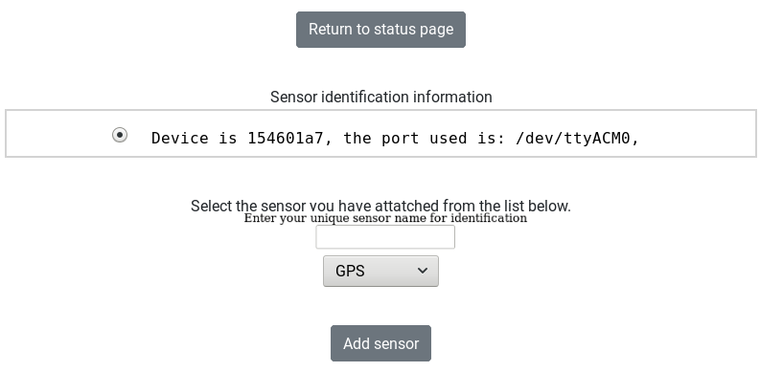

Once you have completed the above steps, click on the “Return to status page” button, and you will see the newly added device.

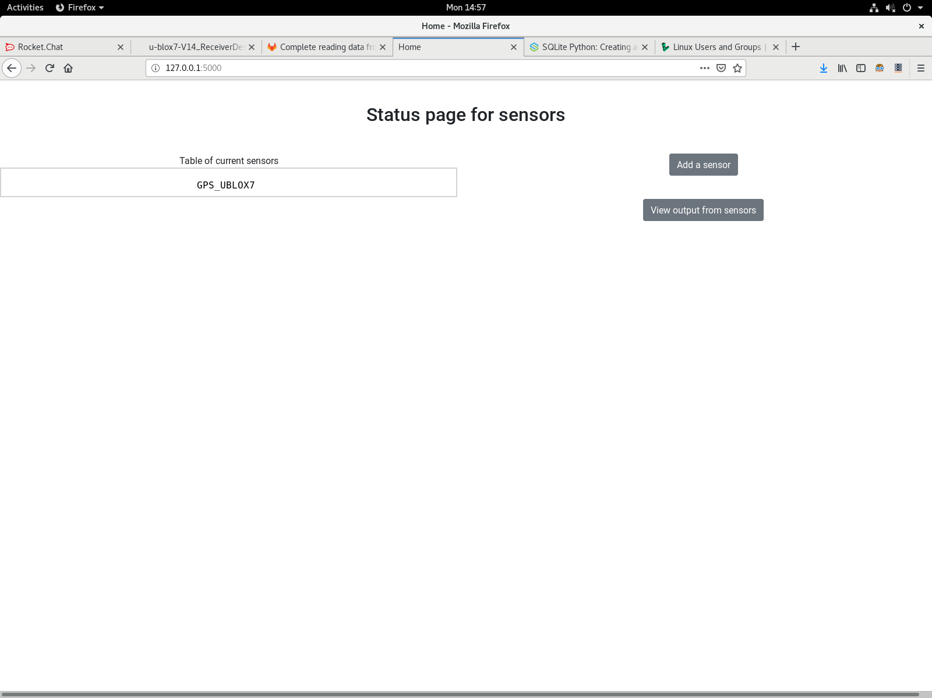

To view the output of the device, click on the “View output from sensors” button in the top right corner. This will redirect you to the page seen in the image below.

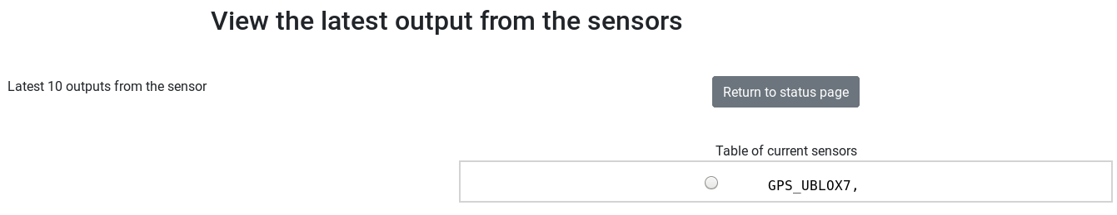

You will see a list of sensors that you are reading from in a table on the right.

To view the output of an individual sensor, click on the button next the to device name.

A table on the left side of the screen shall appear with the latest 10 outputs from that device. To refresh the outputs, you must click on the button next to the device again. See figure below for an example.



To return to the status page, click the button in the top right corner.